**Airius Air Pears and Cooling in Sports Halls - Barriers to a sale put forward by a Mechanical Engineer.**

Airius Oceania recently had an engineer respond to their cooling proposal for a client with these comments, in italics below.

The client was very keen to purchase our units but the engineer’s comments dissuaded the client and they never proceeded with what was a smart and cost-effective solution.

As their comments are generally incorrect or inaccurate, we thought that despite the assorted installations, case studies and testimonials we have in Australia for cooling in large spaces such as sports halls, (Which this proposal was for) we should ‘right the wrongs’ here and reiterate and clarify the value and efficacy of Air Pears performance in summer cooling applications.

* *‘The Air Pear fans proposed operate as a destratification fan (to send the hot air at the top of the gym down to ground level so that the whole gym comes to a constant temperature).’ Engineer*

Airius Air Pears work just like a large bladed fan. Without the blades. In this application, they move air from the roof to floor. They simply do it using much smaller units without large exposed blades. They could also move air horizontally from wall to wall if required. Yet destratification is only part of the story.

If you look at the attached chart of air movement supplied by a large bladed fan manufacturer (at the end of this blog) you can see that the air flow direction and footprint is doing exactly as an Airius Air Pear does.

It is moving warm air from the roof to the floor and then circulating it back up again. Destratification is only part of their story too.

Yet these large fans are used worldwide for cooling. There is no difference in performance between a large bladed fan and an Air Pear when it comes to air circulation. The Air Pears do the same job without exposed large blades and simply require more, but less costly units to achieve the same outcome.

* *‘They are typically used in large warehouses to help reduce energy costs by reducing heat loss from the roof surface.’ Engineer*

**This statement is really incorrect in both assumptions and needs to be clarified.**

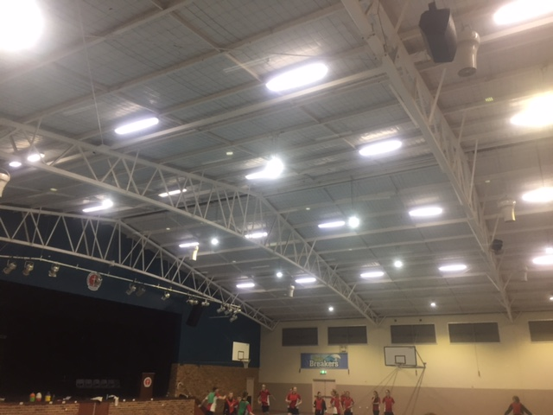

*Airius Air Pears cooling the Green Point Christian College Sports Hall in NSW.*

Considering the largest market for Airius Air Pears worldwide is in Supermarkets, and the units are also used extensively in sports halls, indoor pools, museums, offices, libraries, classrooms, theatres, hospitals, aged care facilities and warehouses, the typical use suggested here is incorrect.

In Australia, there are warehouses using the Airius units and they are all being used for cooling in locales such as Moomba, SA, where it regularly reaches 48-50 Degrees C, and customers such as DHL, Lush Cosmetics and Tyco who use them in hot western Sydney to cool the workers in their warehouses.

Secondly, and more importantly, the use of destratification fans in winter (Large bladed fans are also used in winter to destratify spaces, just not as effectively as Airius Air Pears) is primarily to reduce heating costs by pushing all the lighter warmer air back down to the floor. This is where the largest heating energy savings are achieved. *There is a reduction in heat loss through the roof because the Delta Tin/ Tout is significantly reduced with the use of destratifications fans, resulting in a lower rate of heat loss, but it’s not the prime energy saving opportunity.*

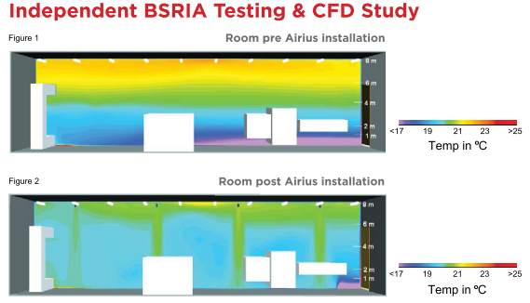

***This CFD graphic from BSRIA highlights the destratification outcomes in a building from using Airius Air Pears***

The prime energy savings opportunity using Airius Fans in winter in a heated building environment, is in the relocating of the warm air in the space back to the floor where it is needed. This stops the over delivery of warm air. Without Airius Air Pears running in a heated space, a client will be wasting large amounts of heated energy by overdelivering warm air to the space to compensate for all the heat rising up and sitting under the roof or ceiling. Energy savings of 20-50% are usually achievable (worldwide) resulting in very low ROI’s if Airius Air Pears are used to destratify a space in winter in a heated building.

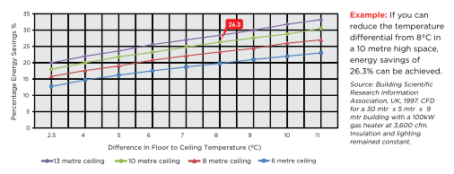

***This chart above from BSRIA UK details the heating energy savings achievable by using Airius Air Pears to destratify in a stratified heated environment.***

* *‘They provide no direct heating or cooling and recirculate the air already in the gym only (i.e. provide no fresh air)’. Engineer*

Well this is sort of correct. If you ignore the significant value of air movement from cooling even in tropical environments then, yes, it is correct, because the Airius Air Pears, and the alternative large bladed fans, or other fan types, are not air-conditioning units and never profess to be.

The recirculation comment is correct but is that a bad thing. Alternatively, if you want, Airius can also bring large amounts of air into or out of the building without the use of expensive ductwork.

However, air movement has been used for cooling people for thousands of years in the warmest and most humid environments. There is also large amount of empirical scientific research around thermal comfort and the value of air movement for cooling in very warm environments and this research highlights the cooling value of air movement at temperature’s up to 36+ Degrees C. (Airius has a great blog on their web site about the value of air movement and cooling)

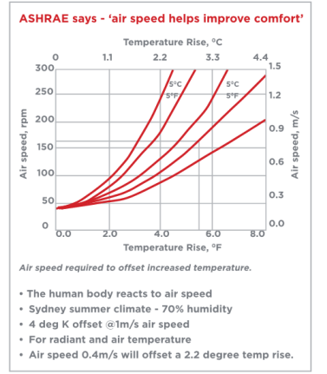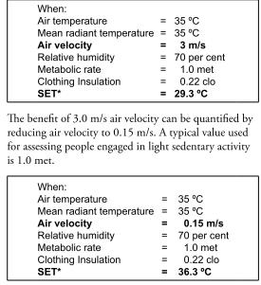

***These charts above are some of many scientific research documents that highlight the value of air movement for cooling in temperate, sub-tropical and tropical climates.***

* *We do not consider they will provide any noticeable air movement at ground level and there are no air movement figures provided with this submission.*

In this case, this statement is incorrect too. There are numerous case studies and testimonials of the Airius Air Pears here in Australia being used for cooling in high activity spaces such has sports halls in hot and humid locations such as Townsville, Rockhampton and the Gold Coast. To create that cooling, they need significant air flow at floor level.

Air movement at floor level is part of Airius’ calculations and design and Airius can provide so much air movement at floor level, if required, they could almost blow people over! This is why Airius has a large range of products and speed controllers, designed to suit every application.

This text below is part of a 2015 testimonial from the Facility Manager at the prestigious Sydney private girls school, SCEGGS, located at Darlinghurst in inner Sydney, contradicting the engineer’s statements above.

*….’The space is a lot more usable in the hotter summer months. We have received great feedback from both the school PE department and also external hirers.*

*High intensity sport is played in the gym now with a lot more comfort. We have the ability to set the fans on five settings ranging from 20%, 40%, 60%, 80% or 100% capacity. It is rare we turn the fans to 100% even though they are 8.5 meters off the playing surface. To put it into context the gymnastic training group can only have the fans on a setting of 3 out of 5 (60%) because it affects the throwing of the ribbon in the air.’*

|  |
| --- |
| **Keith Stevenson**  **Facilities Manager**  **p** 02 9332 1133 | **m** 0477371651  **SCEGGS Darlinghurst | 215 Forbes Street Darlinghurst NSW 2010**  [**www.sceggs.nsw.edu.au**](http://www.sceggs.nsw.edu.au/) |

If requested, Airius can supply the required air flow data.

* *‘In winter, they may help maintain a slightly higher gym temperature by sending warm air from higher in the gym back down to ground level (where the people are). In summer, they will have an adverse effect and may make the gym warmer at ground level.’ Engineer*

This statement above is almost 100% incorrect.

In winter, if you have no heating in your hall there will still be a stratification level where the warmer air in the space sits up at the roof and the Airius units may make the space more comfortable as the engineer notes.

However, the engineer’s comments around no thermal comfort in summer are incorrect as he is ignoring the value of air movement for cooling and also is dismissing the evidence (testimonials) provided by similar building users in warm Australian climates and the reams of scientific and engineering research around the value of air movement for cooling.

Overall, when using Airius Air Pears there is significantly improved thermal comfort in summer. If the correct units are selected incredible amounts of cooling air movement can be created at floor level if needed. No, it’s not air conditioning, but also it doesn’t cost any near what air conditioning costs to buy, install and run.

Air movement in summer is much more comfortable than no air movement in summer.

When considering an Airius Air Pear it’s important to investigate the supplied case studies, testimonials from others in a similar application and the empirical scientific research around air movement and improvements in thermal comfort in warm and humid or hot and dry climates when making an assessment.

***Just because an engineer said so doesn’t mean it’s correct.***

***We have many engineering consultancies here in Australia such as Arups, Aecom, Wood and Grieves, BCA, STP, etc recommending Airius Air Pears for a range of cooling applications.***

Airius can help you understand all of these outcomes and how to achieve them successfully if required.

**Just call Airius on +61 0401 848 888 or email us at info@airius.com.au.**

John Brodie

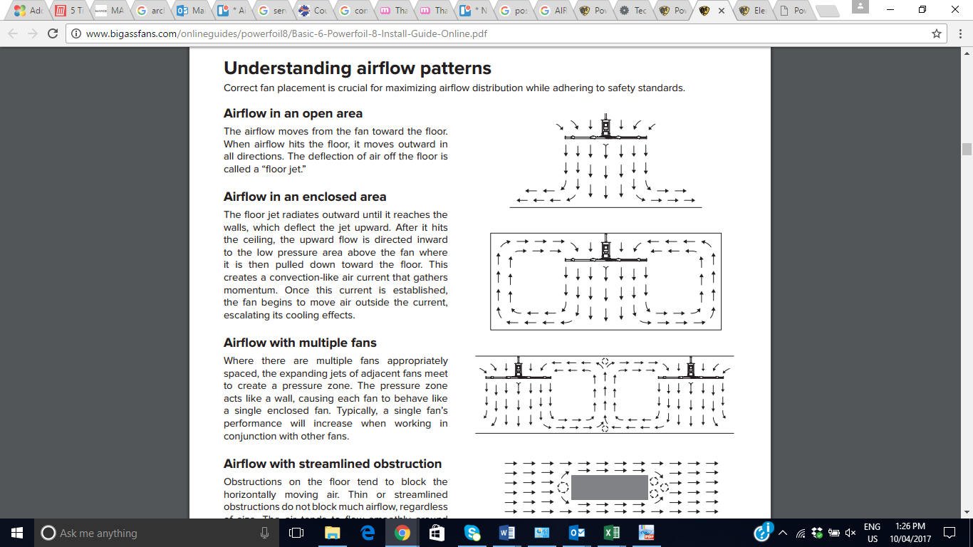

Air flow pattern of a large bladed fan.

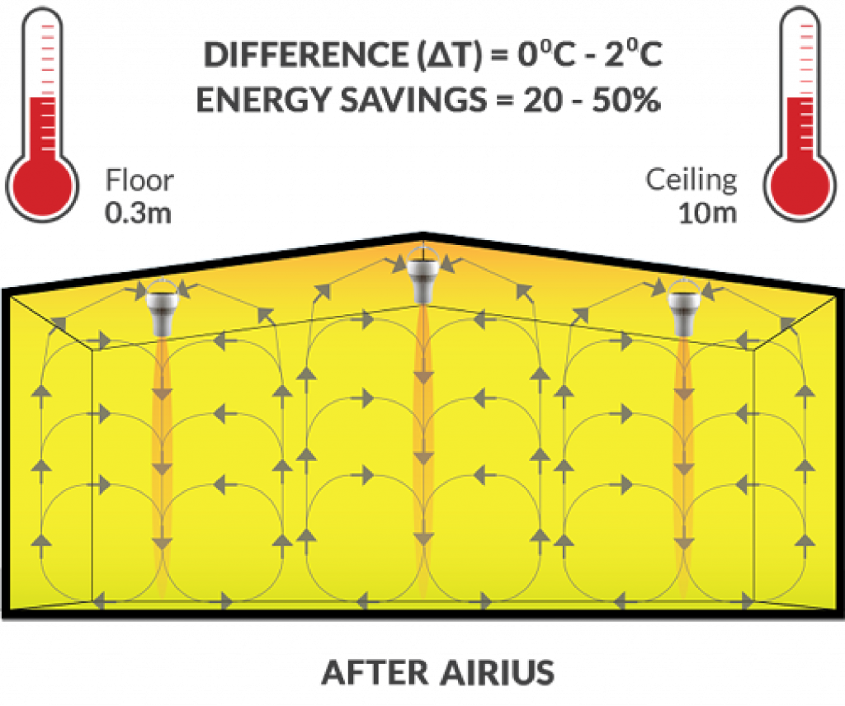

This image above of Airius Air Pear units in operation highlights how the air flow pattern is similar to that of a HVLS product. It’s just that one uses large exposed blades and one doesn’t. Eventually the Air Pears air flow pattern will start to rise back up to the roof again and continue recirculating as does the HVLS fan air flow pattern.

**Same Outcome -different technology.**